*A Project Report on*

“Stock tracker and trend prediction system”

*submitted by*

**Name of the Student Exam Seat Number**

Vedant Hiwarde S1511046

Sahil Nikam S1511014

Prajwal Alekar S1511005

Prajwal Nimbalkar S1511044

*Under the guidance of*

Prof. Kedar Kulkarni



2023-24

Department of Robotics & Automation Engineering

Zeal College of Engineering & Research, Narhe, Pune-41

##### Savitribai Phule Pune University

**Zeal Education Society’s**

**Zeal College of Engineering & Research, Pune-41**

**C E R T I F I C A T E**

This is to certify that Mr. Vedant Ramdas Hiwarde has successfully completed the Project Based Learning with project entitled “*Stock tracker and prediction system”*, under my supervision, the partial fulfillment of Bachelor of Engineering-Robotics & Automation Engineering of Savitribai Phule Pune University.

Date:

Place: Pune

Prof. Kedar Kulkarni Prof. Y.R. Ingole

**Guide Head**

**R & A Engg. Dept.**

Seal

**ACKNOWLEDGEMENT**

I hereby take this opportunity to express my sincere thanks to deep sense of gratitude to my guide **Prof. Kedar Kulkarni sir** for his kind co-operation and encouragement to me during this project. This project wouldn’t be possible without his motivation and ever increasing support. His curiosity, dedication and enthusiasm about the project made this project a success.

I would like to express sincere gratitude to **Prof**. **Y. R. Ingole,** Head of Robotics & Automation Engineering Department for believing in me and nurturing my ideas. I would also like to thank **Prof. P. P. Chakraborty,** (Project Coordinator) for his support, help & cooperation provided for the Project work. I would like to thanks **Prof**. (**Dr.) A. M. Kate,** Principal, Zeal College of Engineering & Research.

I would like to thanks the teaching as well as non-teaching staff of Robotics & Automation Engineering Department for their support. I also acknowledge with thanks, assistance provided by central library staff.

Last, but not least, I would like to thank all my colleagues, friends and most importantly my parents for their valuable co-operation and who believed in me and supported me in their own ways.

Date: Vedant Hiwarde

Place: Pune SE (R&A Engineering)

**ABSTRACT**

India's stock market is an integral part of global stock exchange. It is made up of National Stock Exchange and Bombay Stock Exchange. The total number of companies registered in National Stock Exchange is 2,266, and the number of companies registered with Bombay Stock Exchange is 5,309. The dynamic and volatile nature of Indian stock market necessitates the development of stock prediction system. BSE Sensex (BSE) and Nifty 50 (Nifty 50) are two widely recognized indicators that demonstrate the significance of India’s stock market. Indian stock market provides investors with diverse opportunities and challenges. In addition, benchmark indices (BSE Sensex and Nifty 50) are important indicators of market sentiment as well as economic health. As India’s economy continues to expand, the stock market plays an increasing role in wealth generation, capital allocation and economic development. Therefore, new technologies such as stock prediction systems need to be developed in order to foster investor trust, enhance market efficiency and enable sustained growth in India’s dynamic stock market ecosystem. This prediction system uses data for the stock for about 24 years i.e. from 2000 to 2024. Accurate prediction of stock prices plays an increasingly prominent role in the stock market where returns and risks fluctuate wildly, and both financial institutions and regulatory authorities have paid sufficient attention to it. As a method of asset allocation, stocks have always been favored by investors because of their high returns. The research on stock price prediction has never stopped. This project process data from about 24 years by using the XGBoost (Extreme Gradient Boosting) machine learning algorithm .

**INDEX**

|  |  |  |
| --- | --- | --- |
| **S. No.** | **Description** | **Page No.** |
|  | Certificate | ii |
|  | Acknowledgement | iii |
|  | Abstract | iv |
|  | List of Figures | vi |
|  | List of Tables | vii |
|  | Abbreviations/Nomenclature | viii |
| 1 | Introduction   * 1. Problem Statement   2. Objective |  |
| 2 | Literature Review |  |
| 3 | Methodology |  |
| 4 | Result |  |
| 5 | Conclusion |  |

**LIST OF FIGURES**

|  |  |  |
| --- | --- | --- |
| **Fig. No.** | **Figure Caption** | **Page No.** |
|  |  |  |
|  |  |  |
|  |  |  |
|  |  |  |
|  |  |  |
|  |  |  |
|  |  |  |

**LIST OF TABLES**

|  |  |  |
| --- | --- | --- |
| **Table No.** | **Table Title** | **Page No.** |
|  |  |  |
|  |  |  |
|  |  |  |
|  |  |  |
|  |  |  |
|  |  |  |
|  |  |  |

**ABBREVIATIONS/NOMENCLATURE**

|  |  |
| --- | --- |
|  |  |
|  |  |
|  |  |
|  |  |
|  |  |
|  |  |
|  |  |
|  |  |

**Introduction**

The stock market has long been a focal point for both seasoned investors and researchers alike, drawing widespread attention due to its dynamic nature and potential for substantial gains or losses. Understanding the ever-changing patterns within the stock market and accurately predicting the trajectory of stock prices remains a paramount concern for investors seeking to optimize their investment strategies. The intricate interplay of various factors such as political events, economic indicators, societal trends, and market sentiment collectively influence the fluctuations observed in stock prices. Consequently, the quest for reliable methods to forecast stock price movements has emerged as a perennial area of interest and investigation.

At the heart of this endeavor lies the aspiration to mitigate the inherent risks associated with stock market investments while simultaneously maximizing potential profits. To achieve this objective, researchers and practitioners have turned to a diverse array of techniques and methodologies, with one prevalent approach revolving around the utilization of historical stock market data for predictive analytics. By leveraging historical data encompassing metrics such as opening prices, closing prices, trading volumes, and daily trends, analysts endeavor to discern discernible patterns and trends that may offer insights into future price movements.

The cornerstone of this predictive modeling approach rests on the premise that past performance and historical trends can serve as valuable indicators of future market behavior. By analyzing patterns within the historical data, analysts seek to identify recurring trends, correlations, and anomalies that may inform their predictions regarding future stock price movements. Central to this methodology is the concept of utilizing machine learning algorithms to systematically analyze and interpret vast volumes of historical data, thereby uncovering hidden patterns and relationships that may elude human observation.

Against this backdrop, the primary purpose of the model developed herein is to harness the power of predictive analytics and machine learning to forecast the future trend of stock prices. Specifically, the model endeavors to provide investors with actionable insights into the opening price, lowest price, highest price, closing price, and overall trend of a given stock on any given day. To achieve this objective, the model leverages a network of historical stock market data, extracted from a CSV file, to train and optimize an XGBoost (Extreme Gradient Boosting) machine learning algorithm.

The methodology employed in this endeavor encompasses several key stages, each tailored to facilitate the accurate prediction of stock price movements. Firstly, historical stock market data is sourced from a CSV file, encompassing a comprehensive array of metrics including opening prices, closing prices, trading volumes, and daily trends. Subsequently, present-day data is fetched from Yahoo Finance using the yfinance library in Python, ensuring that the model remains dynamically attuned to real-time market conditions. The model outlined herein represents a concerted effort to harness the power of predictive analytics and machine learning to anticipate future stock price movements with a high degree of accuracy. By leveraging historical data and sophisticated machine learning algorithms, investors are equipped with invaluable insights into the potential trajectory of stock prices, thereby empowering them to make informed investment decisions and mitigate risks effectively. As the field of predictive modeling continues to evolve, this model serves as a testament to the enduring quest for innovation and refinement in the realm of stock market forecasting.. The libraries used in the code of the application are as follows .

* ***Pandas:*** used to load and process data from csv file ,performing the data preprocessing task and data analysis.
* ***XGBoost :*** used to implement the machine learning algorithm and to train the classifier for stock prediction.
* ***Scikit learn:*** Splitting the dataset into training and testing sets, hyperparameter tuning using GridSearchCV, and label encoding.
* ***Tkinter***: used for GUI(graphical user interface).
* ***Tcalender***: used for selection of date.
* ***Yfinance***: used for fetching the financial data on yahoo finance.
* ***OS***: used for checking the files existence and managing file operations.
* ***PIL(python imaging library)*** : loading and setting up background image.

**Literature review**

Research in finance has undergone a profound transformation with the advent of advanced technologies, particularly artificial intelligence (AI) and machine learning (ML), aimed at enhancing stock market analysis and prediction. The exponential growth of data sources in the financial domain, encompassing social media, news sentiment, economic indicators, and alternative data sets, has spurred the development of sophisticated models capable of integrating and analyzing these heterogeneous data streams.

Multi-source heterogeneous data in the stock market encompasses a wide range of information, including traditional financial metrics like stock prices and trading volumes, alongside sentiment analysis of news articles, social media posts, and macroeconomic indicators. This diverse array of data provides invaluable insights into market trends, investor sentiment, and the underlying factors driving stock price movements.While the efficient market hypothesis (EMH) posits that stock prices fully reflect all available information, behavioral finance challenges this notion by suggesting that investor behavior and psychological biases play a significant role in market movements, leading to exploitable inefficiencies. Consequently, research in stock market prediction seeks to identify patterns and signals in data that can be leveraged to forecast future price movements. Machine learning algorithms, notably XGBoost, have emerged as powerful tools for stock market prediction. XGBoost, an ensemble learning technique based on decision trees, has demonstrated remarkable performance across various prediction tasks, including stock price forecasting. By leveraging historical price data, technical indicators, and alternative data sources, XGBoost models can capture complex patterns in the market and generate accurate predictions.

Furthermore, researchers have explored the integration of XGBoost with other machine learning techniques, such as deep learning and natural language processing (NLP), to enhance prediction accuracy further. Hybrid models combining XGBoost with recurrent neural networks (RNNs) or transformer-based architectures have shown promising results in incorporating sequential information from time-series data and textual data from news articles and social media.

In the context of India's stock market, influenced by domestic economic factors, regulatory policies, and global market trends, the demand for accurate prediction models is particularly pronounced. With the rise of algorithmic trading and quantitative investment strategies, there is an increasing need for advanced analytics tools providing real-time insights and decision support to investors and financial institutions. Accurate stock price prediction is valuable not only to investors for optimizing portfolio allocation and risk management but also to regulators for monitoring market stability and detecting potential anomalies or manipulative activities. Harnessing the power of machine learning and big data analytics, stakeholders in the Indian stock market can gain a competitive edge and contribute to the overall efficiency and transparency of the financial ecosystem.

**Methodology**

The methodology employed in developing the Stock Price Tracker & Trend Predictor system encompasses several stages, including data preprocessing, model selection, hyperparameter tuning, user interface design, and system evaluation. This report outlines each step in detail to provide insights into the development process.

**Data Preprocessing**:

The first step involved loading and preprocessing the dataset. The dataset, stored in a CSV file named 'TCS.csv', contains historical stock market data for Tata Consultancy Services (TCS). The 'Date' column was parsed into the correct format, and additional features such as 'Year', 'Month', and 'Day' were extracted to capture temporal information. The target variable, 'Trend', was encoded using LabelEncoder to map bullish (1) and bearish (0) trends to numerical labels.

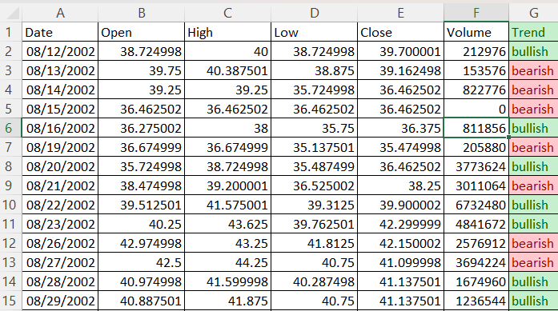

Sample of data stored in CSV file

**Model Selection and Training:**

The XGBoost (Extreme Gradient Boosting) algorithm was selected as the primary model for stock trend prediction due to its effectiveness in handling structured data and capturing complex relationships. The XGBClassifier from the XGBoost library was initialized with default parameters and trained on the preprocessed data. To optimize model performance, hyperparameter tuning was performed using GridSearchCV to search for the best combination of hyperparameters such as 'max_depth', 'learning_rate', and 'n_estimators'. The best-performing classifier was selected based on accuracy scores obtained through cross-validation.

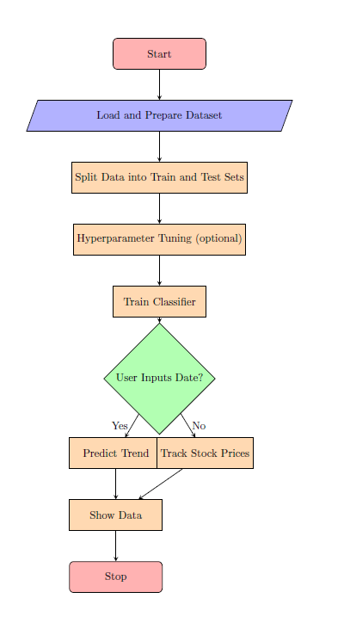

**User Interface Design:**

The graphical user interface (GUI) was developed using the Tkinter library in Python to provide an intuitive and interactive platform for users. The interface includes components such as date selection using the DateEntry widget, entry fields for specifying stock identifiers, and buttons for executing prediction, tracking stock prices, and displaying fetched data. Additionally, a background image was incorporated to enhance the visual appeal of the interface.

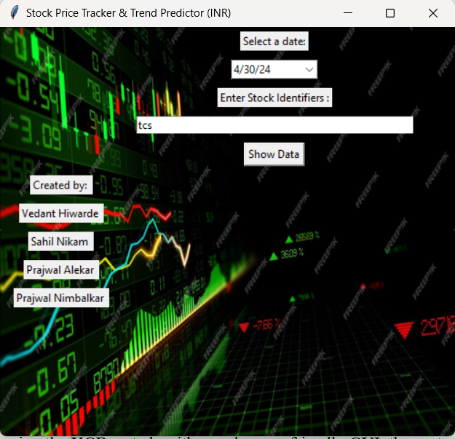

**System Evaluation:**

The system's performance was evaluated through multiple avenues. Firstly, the accuracy of stock trend predictions was assessed using historical data and compared against actual market trends. Secondly, the functionality and usability of the GUI were evaluated through user testing and feedback collection. Any issues or bugs identified during testing were addressed and resolved to ensure the system's robustness and reliability.The methodology employed in developing the Stock Price Tracker & Trend Predictor system involved comprehensive data preprocessing, model selection, hyperparameter tuning, user interface design, and system evaluation. By leveraging the XGBoost algorithm and a user-friendly GUI, the system aims to provide accurate stock trend predictions and empower users to make informed investment decisions. Continuous refinement and updates will be made based on user feedback and market dynamics to enhance the system's effectiveness and usability.

**Result**

After the application of each step of the methodology, we get the final result.

To make a stock analysis or prediction we can find the trend of the particular stock (TCS as per project) just by entering the date.

Whenerver the date is entered in the software with help of stored data and Ml alogorithm carries on its analysis and presents a trend (bullish or bearish) as output and stock prediction is carried better accuracy as compared to earlier techniques or methods.

Along with the prediction the software also implies a tending hand to know the prices (open, close, low, high )for the present day.

Due to this, there will be no overdependency on the software, and running parallel to the software analysis human analysis can be done .



**Conclusion**:

As we have already mentioned that stock market is major contrbuter to economy and numerous people especially beginners and young ones highly invest in stock market in order to achieve higher returns ,but due to lack of data, knowledge and poor analysis they suffer huge debt.

Dur to which hearing form the experiences of this beginers the next generation interested in

Investment in not as keen due to their past experiences .

But this project or software consists data of last 24 years and Machine Learning is used to study the data and predict the trend due to which the analysis has become much easier.

Hence the users especially the beginners mentioned before would find it easier to analyse and invest and ensure the pillar of economy goes strong.